
Worksheet 8
Student Name: Arnab Lala UID: 25MCI10232
Branch: M.C.A(A.l & M.L) Section/Group: MAM-1 A
Semester: 2nd Sem Date of Performance:12/01/2026
Subject Name: Technical Skills Subject Code: 25CAP-652_25MAM_KAR-1(A)
AIM: To apply the concept of Stored Procedures in database operations in order to perform tasks like insertion, updating, deletion, and retrieval of data efficiently, securely, and in a reusable manner within the database system.
S/W Requirement: Oracle Database Express Edition and pgAdmin
OBJECTIVES:
- To understand the concept and usage of stored procedures in database systems.
- To implement stored procedures for performing CRUD operations efficiently.
- To enhance data security by restricting direct access through stored procedures.
- To reduce code redundancy by using reusable database procedures.
To improve performance of database operations using precompiled stored procedures
Practical / Experiment Steps:
Step 0 Setup (Tables Structure-Employees)
CREATE TABLE staff (
staff_id INT PRIMARY KEY,
staff_name VARCHAR(50),
salary NUMERIC(20,3)
);
INSERT INTO staff VALUES
(1, 'Rahul', 20000),
(2, 'Neha', 30000),
(3, 'Amit', 25000);
select * from staff;
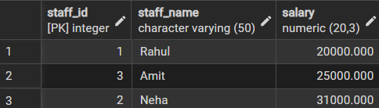
-- Step 1: Create Procedure for Salary Increment
CREATE OR REPLACE PROCEDURE increment_salary_proc(
IN P_STAFF_ID INT,
INOUT P_INCREMENT NUMERIC(20,3),
OUT RESULT_STATUS VARCHAR(25)
)
AS
$$
DECLARE
NEW_SAL NUMERIC(20,3);
BEGIN
-- Calculate new salary
SELECT salary + P_INCREMENT
INTO NEW_SAL
FROM staff
WHERE staff_id = P_STAFF_ID;
-- If not found
IF NOT FOUND THEN
RAISE EXCEPTION 'STAFF NOT FOUND';
END IF;
-- Update salary
UPDATE staff
SET salary = NEW_SAL
WHERE staff_id = P_STAFF_ID;
-- Return values
P_INCREMENT := NEW_SAL;
RESULT_STATUS := 'UPDATED SUCCESSFULLY';
EXCEPTION
WHEN OTHERS THEN
IF SQLERRM LIKE '%STAFF NOT FOUND%' THEN
RESULT_STATUS := 'STAFF NOT FOUND';
ELSE
RESULT_STATUS := 'ERROR OCCURRED';
END IF;
END;
$$ LANGUAGE plpgsql;
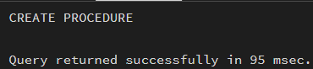
DO
$$
DECLARE
V_STAFF_ID INT := 2;
V_STATUS VARCHAR(25);
V_INCREMENT NUMERIC(20,3) := 1000;
BEGIN
CALL increment_salary_proc(V_STAFF_ID, V_INCREMENT, V_STATUS);
RAISE NOTICE
'STATUS: % | UPDATED SALARY: %',
V_STATUS, V_INCREMENT;
END;
$$;
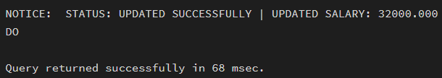
Outcomes:
- To demonstrate the ability to create and execute stored procedures for various database operations.
- To apply stored procedures for performing secure and efficient CRUD operations.
- To analyze the impact of stored procedures on database performance and execution efficiency.
- To design modular and reusable database logic using stored procedures.

